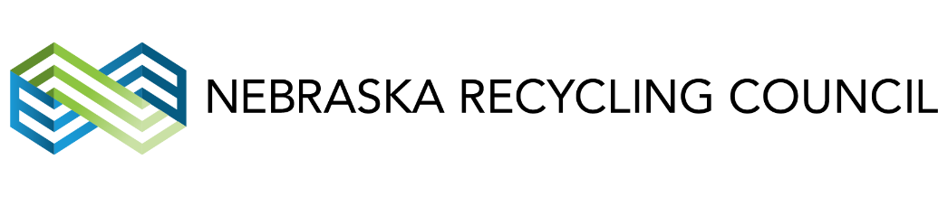

FOR IMMEDIATE RELEASE: March 31, 2017

Contact:
Heather Creevan, Operations and Communications Director
Nebraska Recycling Council
hcreevan@nrcne.org
402-436-2384 x1002

LINCOLN, NEBR. - Two of Nebraska’s pre-eminent environmental non-profit organizations, the Nebraska State Recycling Association (NSRA) and WasteCap Nebraska will merge on March 31, 2017. The new entity will be called the Nebraska Recycling Council (NRC). NRC’s mission is to maximize the economic and environmental benefits of resource recovery in Nebraska.
The two organizations believe their union will have a much stronger, farther reaching impact than they did as separate entities. “The merger will eliminate overlap in our programs, and the new organization will concentrate on coordinating partnerships across Nebraska regions, between communities, service providers, solid waste managers, haulers, business and end markets,” said Julie Diegel, executive director for NSRA and now NRC.
"Both NSRA and WasteCap have a long history of serving Nebraska in the field of Solid Waste and Recycling. By combining those efforts, NRC will be able to do more towards building partnerships, advancing resource recovery, and maximizing the benefits for both our members and the state of Nebraska," added Danielle Easdale, WasteCap Nebraska’s board president and newly elected NRC president.
Since 1980, NSRA has assisted hundreds of communities, nonprofits and businesses, providing over $2.6 million in Nebraska Environmental Trust grants for recycling equipment, and delivered publications, professional training and advocacy on a wide range of recycling topics. WasteCap Nebraska, meanwhile, has helped tens of thousands of Nebraskans since 1992, providing the state’s most comprehensive online recycling guide, business waste assessments, education and professional training, community zero waste assistance programs and advocacy.
###
The Nebraska Recycling Council headquarters is located at 610 J Street, Suite 300, Lincoln, Nebraska, 68508. The web site is nrcne.org and the phone number is 402-436-2384. Julie Diegel is the Executive Director, Heather Creevan is the Operations and Communications Director and Megan Jackson is Program Manager.

